***Heatmap***

***Description***

* *This is an Android application that provide a heatmap of a Calculator.*

***Usage***

* *When the user opens the application this screen opens at first*

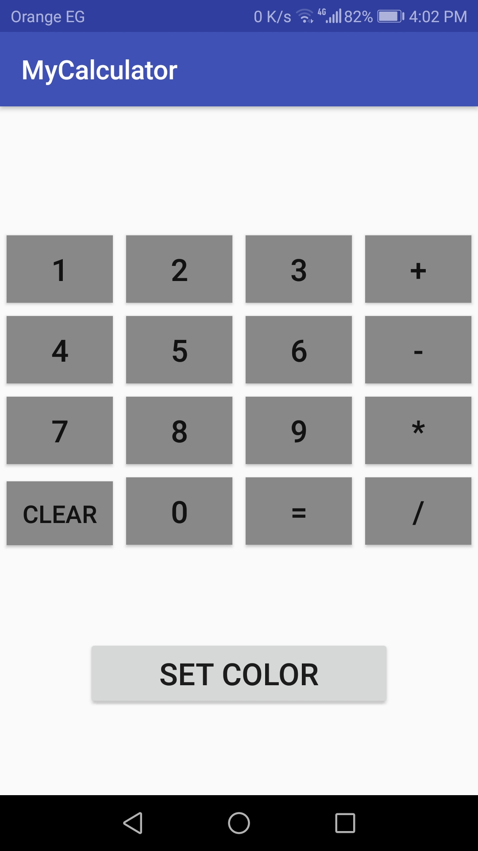

* *Then the aim is to let the user uses the calculator normally and while the user uses the calculator the screen will be colored like this.*

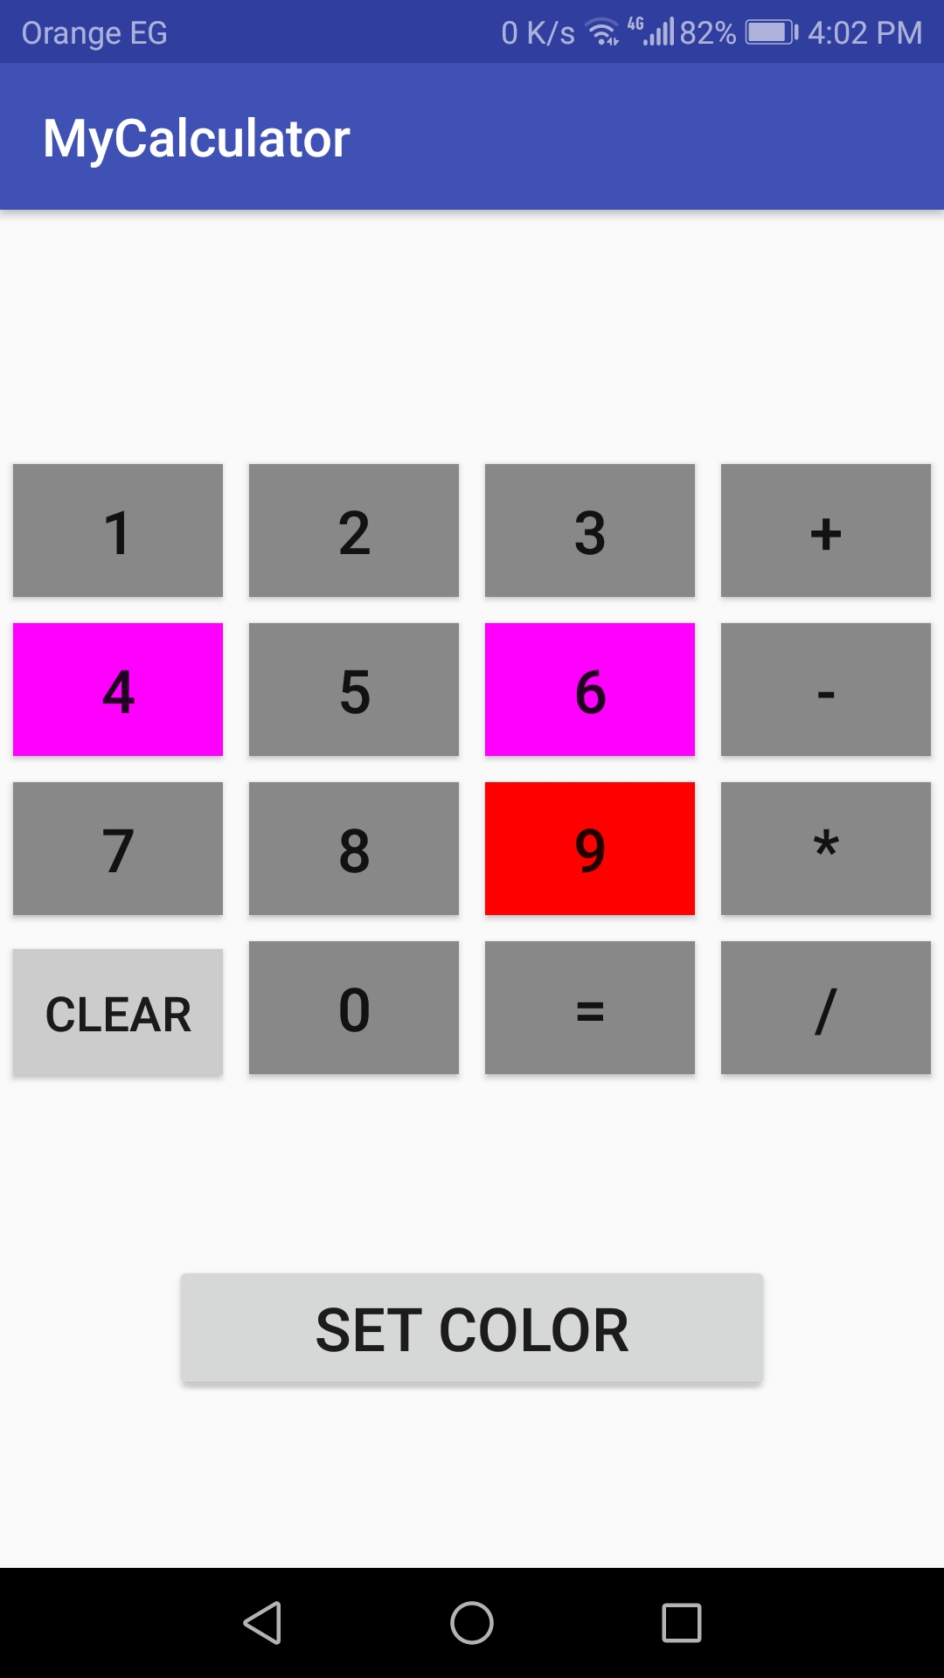

* *If the user want to change the colors of each level the user will click on set color button and a new page will open*

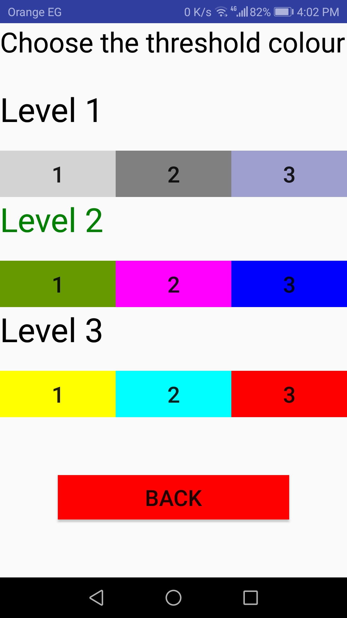

* *Then user should click on the preferred colors and when finished the user should click on the Back button.*

***Purpose***

* *The purpose of the heatmap in this application is to show the developers what does the user uses more frequently and what the user doesn’t use often.*
* *So the developers based on this data can develop a UI that is easy and attractive for the users.*